bc  

**MEMO Number** CMPE320_S21-PROJ2

**DATE:** 3/29/2021

**TO:** EPC LaBerge and CMPE320 Peers

**FROM:** Nem Negash

**SUBJECT: Project 2 Report**

# introduction

This project was focused on the pdf of functions of a random variable. The three sections of the project involve analytical computations as well as simulations. The project topic is described as follows:

The engineers at Universally Marvelous Broadcasting and Communications (UMBC) are designing how to detect the amplitude or the power of a bipolar signal of known amplitude that is corrupted by Additive White Gaussian Noise (AWGN)1. Three methods have been suggested:

1. When the signal is received, it is passed the signal through a perfect diode detector, and only the positive values are used; or,
2. When the signal is received, the processor computes the amplitude by taking the absolute value of measured signal; or,
3. When the signal is received, the processor computes the amplitude squared by taking the square of the measured signal, thus producing an estimate of the *power*.

# simulation and discussion

## Method 1

### Analytical PDF

Using the CDF method developed in class, analytically derive the probability density function for *s*(*t*), *fS*(*s*), where *s*(*t*) is the signal that is actually processed using the first method. For this element, please use the symbolic (not numeric) values of *A* and σ2.

Expressing the appropriate functional expression of Method 1 as *Y*=*g*(*X*), compute

*Y*=*g*(*E*[*X*]), that is the function evaluated at the expected value of the random variable *X*. Save this value for use in 2.4

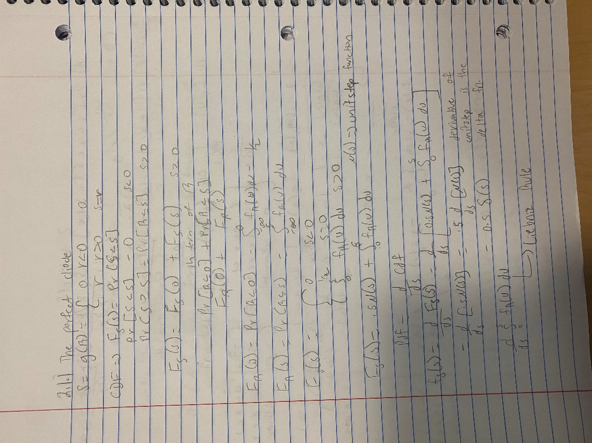

Figure 1: Analytical Computations for 2.1 part 1

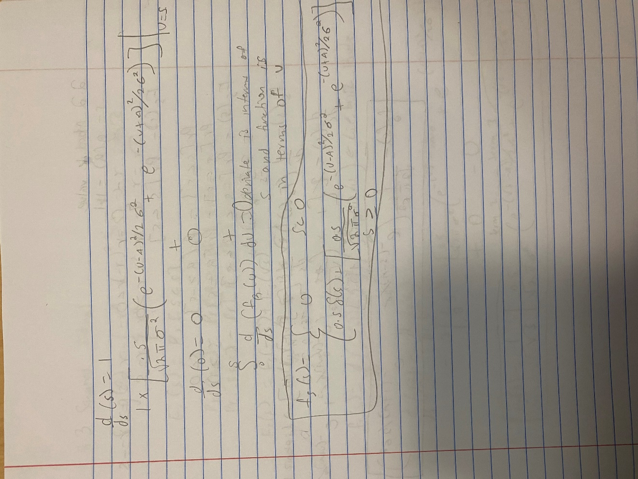

Figure 2: Analytical Computations for 2.1 part 2

### Simulated PDF

Using the techniques developed in Project 1, generate a large number of random trials from an appropriate distribution and simulate the probability density function *fS*(*s*). Plot the histogram-based pdf, and then plot the analytical pdf you derived in 2.1.1 on the same set of axes. Provide a professional plot.

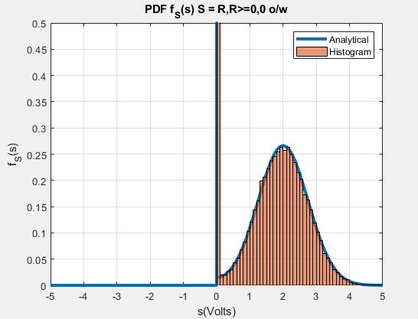

Figure 3: Analytical and Simulated PDF for 2.1

**Figure 3** shows the analytical PDF and simulation histogram for method 1. The histogram represents the data for 100,000 trials. For this method the analytical function was a piecewise function where the random variable S was read as 0 for any value S ≤ 0. The simulation was conducted by using the rand and randn MATLAB functions to simulate the voltage signal with an amplitude A = 2 and noise variance of σ2 = 9/16. All produced signals less than zero were read as zero. This set of simulated signals is then used to generate the histogram and calculate the Jensen’s Inequality. The plot shows that the value for the PDF at zero is 0.5 since all the negative voltage signals are read as zeros which is about 50% of the signals.

## Method 2

### Analytical PDF

Using the CDF method developed in class, analytically derive the probability density function for *s*(*t*), *fS*(*s*), where *s*(*t*) is the signal that is actually processed using the second method. For this element, please use the symbolic (not numeric) values of *A* and σ2.

Expressing the appropriate functional expression of Method 2 as *Y*=*g*(*X*), compute

*Y*=*g*(*E*[*X*]), that is the function evaluated at the expected value of the random variable *X*. Save this value for use in 2.4

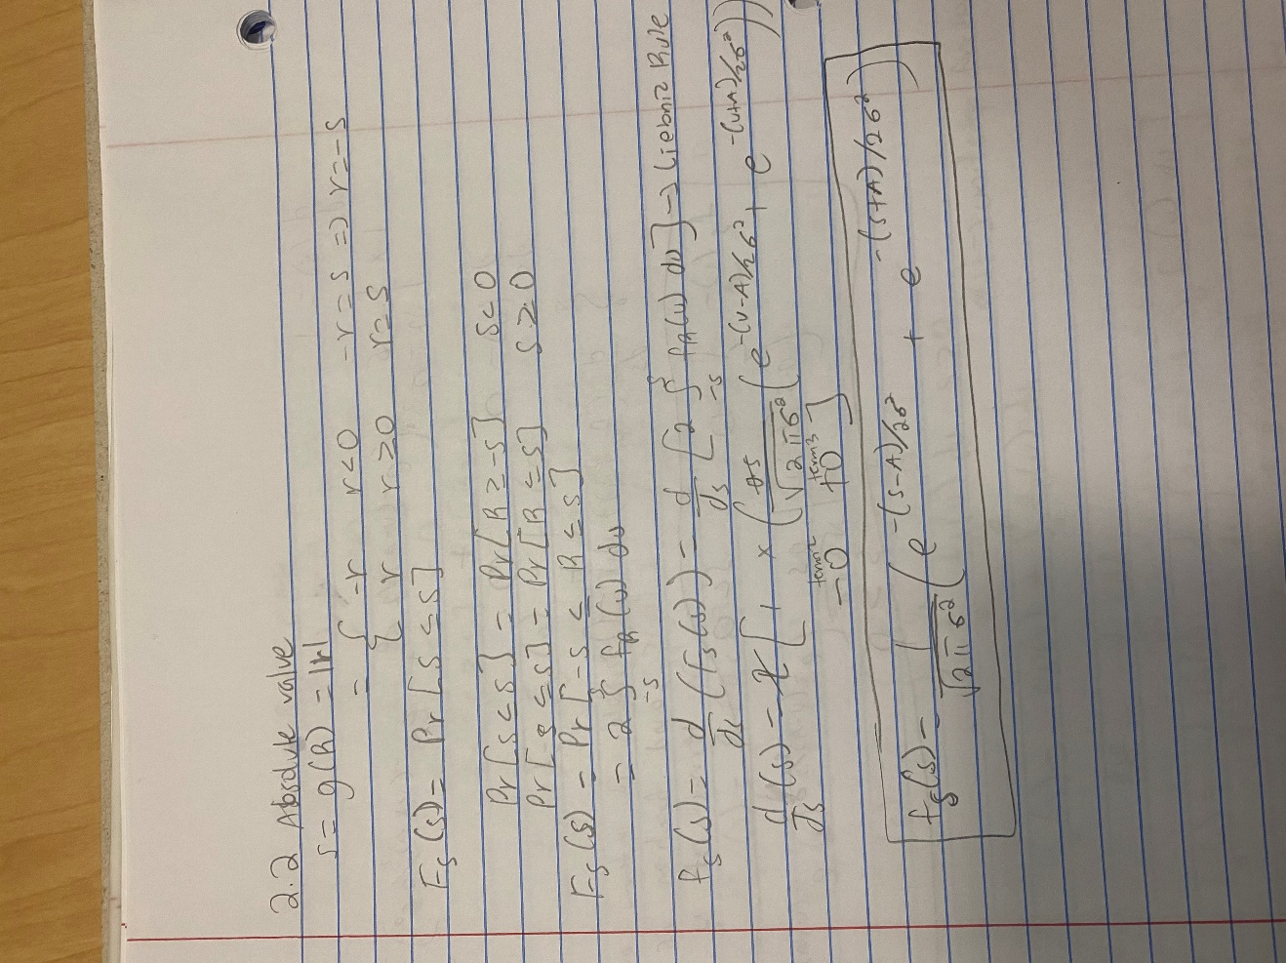

Figure 4: Analytical Computations for 2.2

### Simulated PDF

Using the techniques developed in Project 1, generate a large number of random trials from an appropriate distribution and simulate the probability density function *fS*(*s*) . Plot the histogram-based pdf, and then plot the analytical pdf you derived in 2.2.1 on the same set of axes. Provide a professional plot.

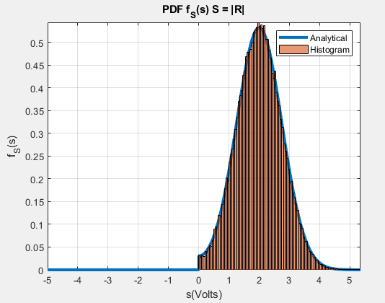

Figure 5: Analytical and Simulated PDF for 2.2

**Figure 5** shows the analytical PDF and simulation histogram for method 2. The histogram represents the data for 100,000 trials. For this method the analytical function represented the PDF of the random variable S which is the absolute value of the measured signal. The simulation was conducted by using the rand and randn MATLAB functions to simulate the voltage signal with an amplitude A = 2 and noise variance of σ2 = 9/16. The absolute value of the produced signal is then used to generate the histogram and calculate the Jensen’s Inequality.

## Method 3

### Analytical PDF

Using the CDF method developed in class, analytically derive the probability density function for *s*(*t*), *fS*(*s*), where *s*(*t*) is the signal that is actually processed using the second method. For this element, please use the symbolic (not numeric) values of *A* and σ2.

Expressing the appropriate functional expression of Method 3 as *Y*=*g*(*X*), compute

*Y*=*g*(*E*[*X*]), that is the function evaluated at the expected value of the random variable *X*.

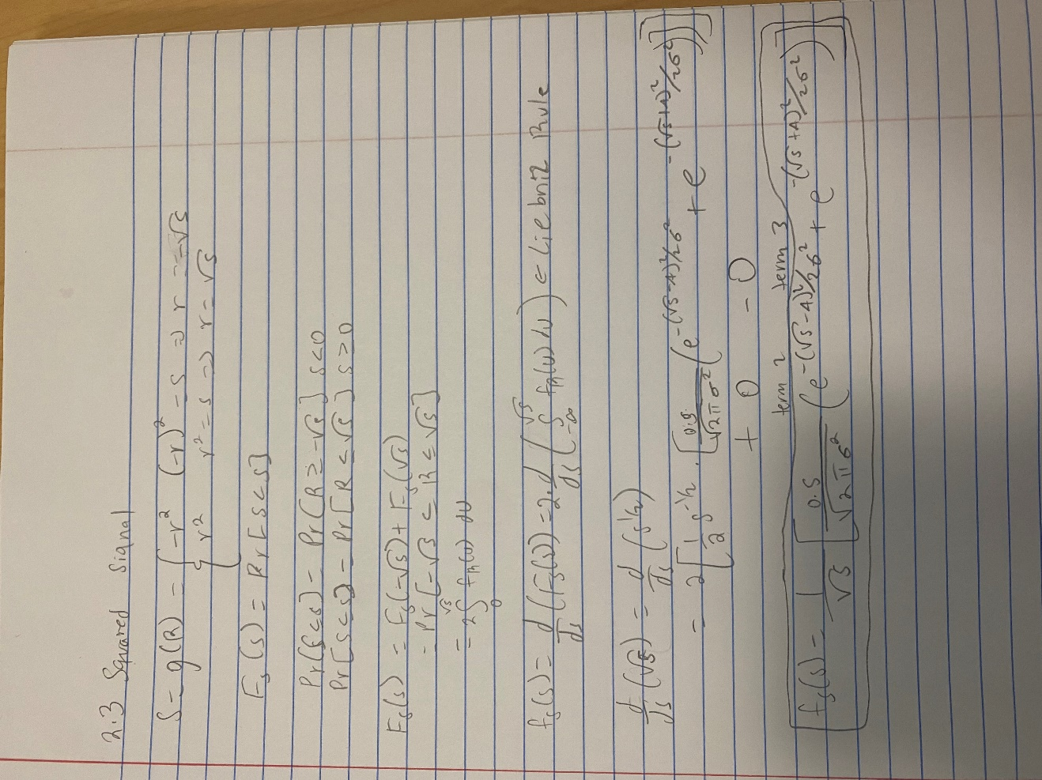

Figure 6: Analytical Computations for 2.3

### Simulated PDF

Using the techniques developed in Project 1, generate a large number of random trials from an appropriate distribution and simulate the probability density function *fS*(*s*). Plot the histogram-based pdf, and then plot the analytical pdf you derived in 2.3.1 on the same set of axes. Provide a professional plot.

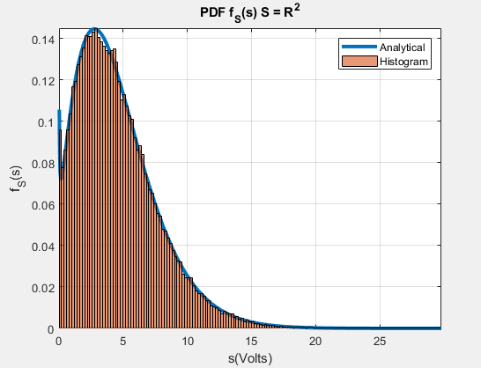

Figure 7: Analytical and Simulated PDF for 2.3

**Figure 7** shows the analytical PDF and simulation histogram for method 3. The histogram represents the data for 100,000 trials. For this method the analytical function represented the PDF of the random variable S which is the squared value of the measured signal. The simulation was conducted by using the rand and randn MATLAB functions to simulate the voltage signal with an amplitude A = 2 and noise variance of σ2 = 9/16. The squared value of the produced signal is then used to generate the histogram and calculate the Jensen’s Inequality.

## Looking Ahead: Jensen’s Inequality

For each of three methods, compare the expected value of the simulated data with the evaluation of the function at the expected value. Is there a consistent inequality relationship that extends across the three cases. Can you guess the general rule, which is known as Jensen’s Inequality.

The Jensen’s Inequality rule states that for any convex function g, that E[g(x)] ≥ g[E(x)]. The Jensen’s Inequality evaluation for each section is as follows:

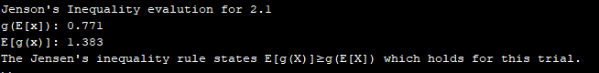

Figure 8: Jenson's Inequality for 2.1

**Figure 8** shows the Jenson’s Inequality for section 2.1. The mean of the random variable R = X+N which is g[E(x)] is less than E[g(x)]. This large difference is caused by the delta function that’s part of the analytical function which accounts for all the negative voltage signals that are read as 0.

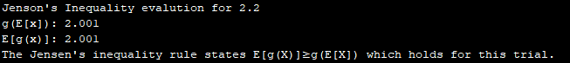

Figure 9: Jensen's Inequality for 2.2

Figure 9 shows the Jenson’s Inequality for section 2.2. Both values where equal which still holds for the Jenson’s inequality rule. This makes sense since the absolute value of each voltage signal is taken, and all inputs are considered valid unlike section 2.1.

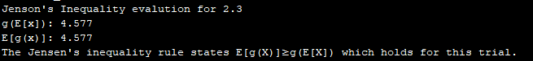

Figure 10: Jenson's Inequality for 2.3

Figure 10 shows the Jenson’s Inequality for section 2.3. Both values where equal which still holds for the Jenson’s inequality rule. This makes sense since the squared value of each voltage signal is taken, and all inputs are considered valid unlike section 2.1.

# what i learned

This project has really given me a much better understanding of random variable PDFs and the Jensen’s Inequality rule by using the model of a voltage signal with additive white gaussian noise (AWGN). For PDFs, I also learned how to simulate the analytical functions using a set of trials to simulate the random variable. This project has also expanded my understanding of MATLAB functions by using functions such as piecewise, dirac, and syms and the different types of files MATLAB provides such as scripts and live scripts.

## Future suggestions

This project overall was good. It was concise, instructive, helped me learn a lot about MATLAB, and strengthen my understandings of the topics covered in lecture.

## Time spent

|  |  |
| --- | --- |
| Topic | Time Spent |
| Reading | 5 hours |
| Research | 8 hours |
| Programming | 15 hours |
| Writing | 10 hours |
| Final Preparation | 2 hours |
| **Total:** | 40 hours |